Wire Trail Maker Tool
Purpose
This tool is supposed to be used for creating pre-made wire chains. It will highlight valid items to add to the chain. The nearest object in range that is valid to be added at any given time will be highlighted.
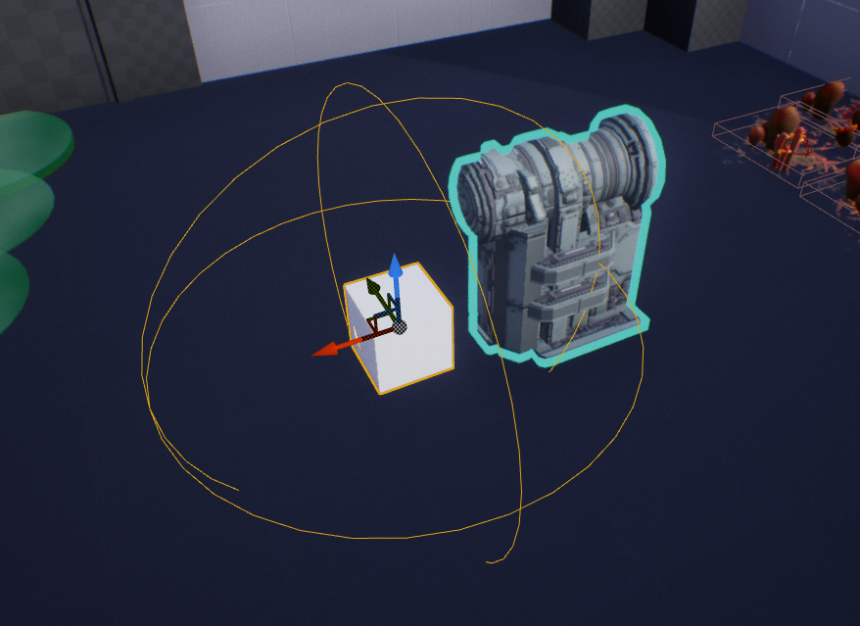
The tool highlighting a valid powered object
Use Range
The range of the tool can be altered by using the MRange slider. It will change the radius of the sphere that the tool uses to find relevant objects.

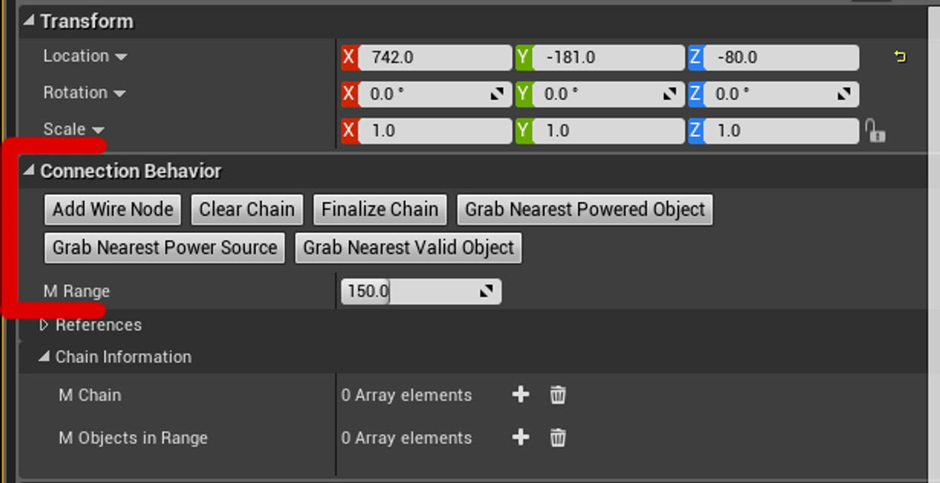
All the needed functions are here

Functions
AddWireNode - This will add a wire node directly underneath the tool and add it to the current chain. This cannot be used unless either an electronic object or power source is in the chain.
ClearChain - This will traverse the chain, clear the reference from the electronic object and/or power source and delete all the wire nodes in the chain.
FinalizeChain - This will clear all the references in the tool and leave the chain in the scene. Now the tool can be used again to create a new chain.
GrabNearestPoweredObject - This will grab the nearest powered object in range and put it in the chain, assuming there isn't already one in the chain.
GrabNearestPowerSource - This will grab the nearest power source in range and put in it the chain, assuming there isn't already one in the chain
GrabNearestValidObject - This will grab the nearest relevant object depending what is in the chain. This will rewrite the connections in the affected objects and will take wires from other chains, breaking them.

Examples:
- If there is nothing in the chain it will grab the nearest power source or powered object in range.
- If there is only a powered object or power source in the chain only a wire can be added.

Example Gif

